FY6000系列DDS频率校准方法

FY6000 Series DDS Frequency calibration method

操作方法如下：

Operating methods are as follows:

1、在关机状态下，同时按下前面板电源键和CH1通道按键，如下图所示：

1、In the shutdown state, press the Power button and CH1 channel button on the front panel at the same time, as shown below：

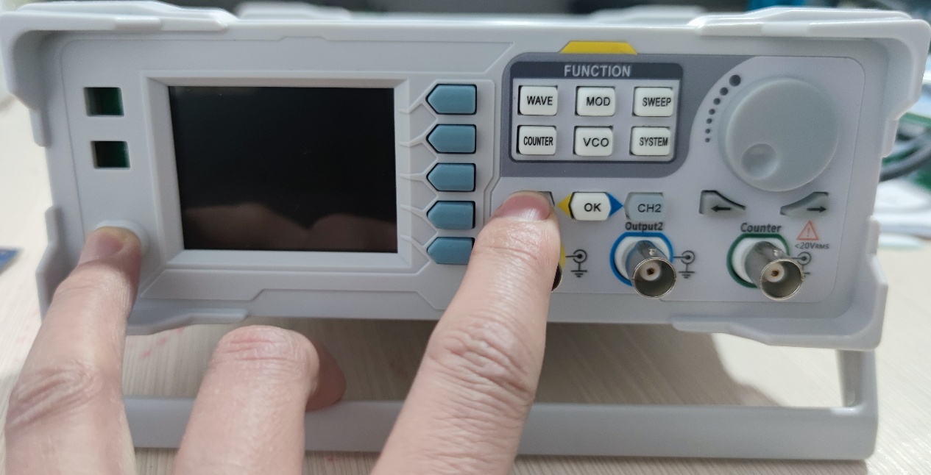

2、打开仪器后面板电源开关，等待2S，松开前面板电源键和CH1通道按键，仪器进入开机界面，如下图所示：

2、Turn on the power switch on the rear panel of the instrument, wait for 2S, release the Power button and CH1 channel button on the front panel, and the instrument enters the working interface, as shown below:

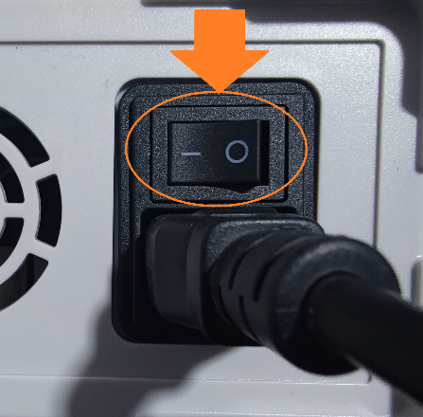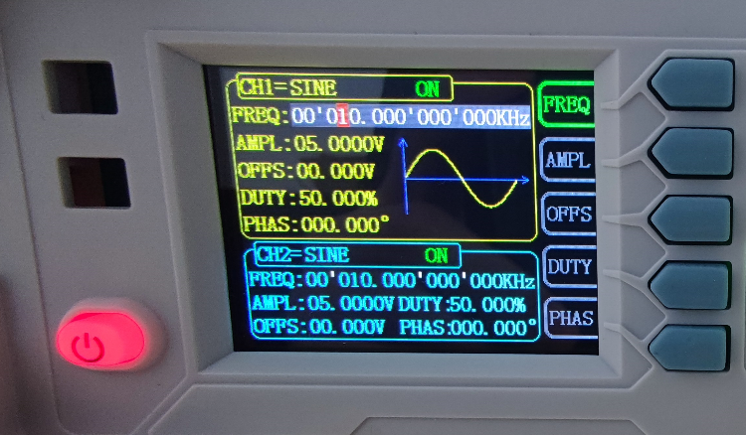

3、点击“SYSTEM”按键，进入系统界面后，点击屏幕右下角“更多”按键。

3、Click the "system" button to enter the system interface, and then click the "more" button in the lower right corner of the screen.

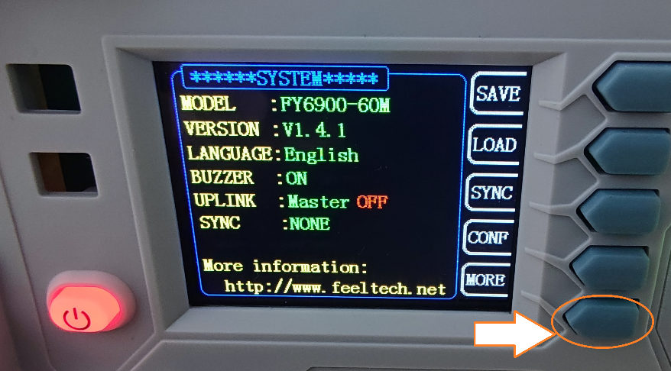

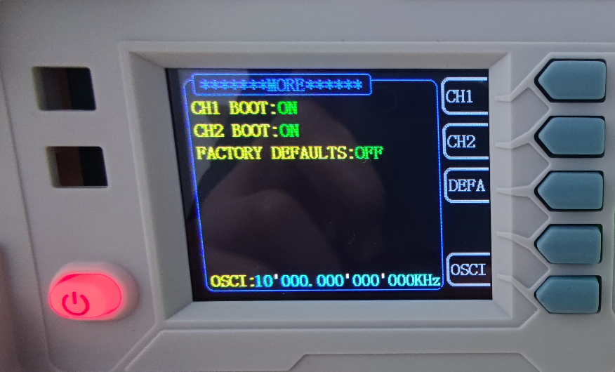

4、进入MORE界面后点击屏幕右下角“晶振”按键。用示波器测量CH1通道输出的频率，如果测量到的频率低于10.00000KHz，就逆时针旋转参数调节旋钮减小对应数值。当测量到的CH1通道输出频率为10KHz时，向下按动参数调节旋钮(OK按键)，然后断电，再开机，频率校准完成。

4、After entering the more interface, click the "OSCI" button in the lower right corner of the screen. Use the oscilloscope to measure the frequency of the CH1 channel output. If the measured frequency is less than 10.00000KHz, turn the parameter adjustment knob counterclockwise to decrease the corresponding value. When the measured output frequency of CH1 channel is 10kHz, press down the parameter adjustment knob (OK button), then turn off the power and start again, and the frequency calibration is completed.

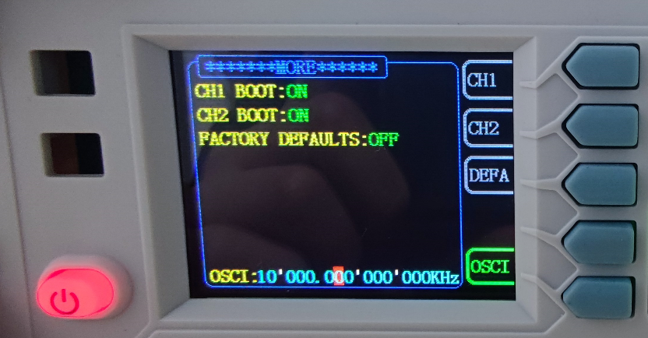

Technical Support E-mail:feeltech@126.com